Birth Data Report

Allison Young

October 10, 2018

### Printed Summary of File

textsummary(fname,births)

## [1] " smoking.csv : This file has 869 rows, and 12 columns"  
## [1] "The varible names are id, date, gestation, bwt.oz, parity, mrace, mage, med, mht, mpregwt, inc, smoke"

### Explored Data

Explored diminsions of the file and summaries of variables.

## [1] " file : This file has 869 rows, and 12 columns"  
## 'data.frame': 869 obs. of 12 variables:  
## $ id : int 4604 7435 7722 2026 3553 3491 6757 6153 8187 8403 ...  
## $ date : int 1598 1527 1563 1503 1638 1705 1444 1405 1669 1669 ...  
## $ gestation: int 148 181 204 225 233 234 234 235 236 241 ...  
## $ bwt.oz : int 116 110 55 132 105 85 97 129 63 128 ...  
## $ parity : int 7 7 11 4 4 7 0 3 0 0 ...  
## $ mrace : int 7 7 7 7 7 7 6 7 5 7 ...  
## $ mage : int 28 27 35 28 34 33 26 24 24 17 ...  
## $ med : int 1 1 3 2 3 1 5 4 5 1 ...  
## $ mht : int 66 64 65 67 61 67 65 66 58 64 ...  
## $ mpregwt : int 135 133 140 148 130 130 112 135 99 126 ...  
## $ inc : int 2 1 6 3 3 2 6 1 7 2 ...  
## $ smoke : int 0 0 0 0 0 0 0 0 0 0 ...  
## NULL  
## id date gestation bwt.oz   
## Min. : 15 Min. :1350 Min. :148.0 Min. : 55.0   
## 1st Qu.:5477 1st Qu.:1444 1st Qu.:272.0 1st Qu.:108.0   
## Median :6734 Median :1540 Median :279.0 Median :119.0   
## Mean :6032 Mean :1536 Mean :278.5 Mean :118.4   
## 3rd Qu.:7587 3rd Qu.:1627 3rd Qu.:286.0 3rd Qu.:129.0   
## Max. :9263 Max. :1714 Max. :338.0 Max. :174.0   
## parity mrace mage med   
## Min. : 0.000 Min. :0.000 Min. :15.00 Min. :0.000   
## 1st Qu.: 1.000 1st Qu.:0.000 1st Qu.:23.00 1st Qu.:2.000   
## Median : 2.000 Median :2.000 Median :26.00 Median :2.000   
## Mean : 1.953 Mean :2.995 Mean :27.29 Mean :2.932   
## 3rd Qu.: 3.000 3rd Qu.:7.000 3rd Qu.:31.00 3rd Qu.:4.000   
## Max. :11.000 Max. :9.000 Max. :45.00 Max. :7.000   
## mht mpregwt inc smoke   
## Min. :53.00 Min. : 87.0 Min. :0.000 Min. :0.0000   
## 1st Qu.:62.00 1st Qu.:113.0 1st Qu.:2.000 1st Qu.:0.0000   
## Median :64.00 Median :125.0 Median :3.000 Median :0.0000   
## Mean :64.07 Mean :128.5 Mean :3.681 Mean :0.4638   
## 3rd Qu.:66.00 3rd Qu.:140.0 3rd Qu.:5.000 3rd Qu.:1.0000   
## Max. :72.00 Max. :220.0 Max. :9.000 Max. :1.0000

### Predictor Variable Transformations and Labeling

-Changed bwt.oz to bwt, mean centered date variable and re-visited converting date variables to strings for interpretation. -Created a new column, “mracetxt” to hold the new race variable names, “White” (categories 0-5), “Mexican”, “Black”, “Asian”, and “Mix”. -Created new label columns for mother education and mother income. -Plotted histograms and box plots of x variables for both continuous and categorical variables. -Will need to also change gestation to a boolean variable for logistic regression analysis

## II. Exploring Relationships

Outcome Variable: Pre-term Birth (gestpreterm)

First, I mapped a series of plots between birth term (pre-term or full-term) and predictor variables, and looked at the relationship between birth term and smoking.

#### Pre- Term Births

## Min. 1st Qu. Median Mean 3rd Qu. Max.   
## 0.0000 0.0000 0.0000 0.1887 0.0000 1.0000

With a mean of .1887 for the modified gestation variable, we know approximately 19% of the births in this data set were preterm.

#### Smoking Status

tapply(births$gestation, births$smoketxt, mean)

## Non-Smoker Smoker   
## 0.1652361 0.2158809

We can also see that there is a difference in preterm outcomes based on the smoking status of mothers, with 22% of mothers who smoke giving birth to preterm babies whereas about 17% of Non-smoking mothers gave birth to preterm babies.

#### Continuous Variables

tapply(births$gestation, births$mracetxt, mean)

## Asian Black Mexican Mix White   
## 0.32352941 0.26627219 0.24000000 0.06666667 0.16134185

tapply(births$gestation, births$medtxt, mean)

## 8th to 12th, No Grad College Grad   
## 0.2769231 0.1698113   
## HS Grad and Trade HS Grad Only   
## 0.2340426 0.1900312   
## HS Grade and Some College Less than 8th Grade   
## 0.1182266 0.4000000   
## Trade School (HSG Unknown)   
## 0.7500000

tapply(births$gestation, births$inctxt, mean)

## 10000-12499 12500-14999 15000-17499 17500-19999 20000-22499 22500+   
## 0.1904762 0.2040816 0.1929825 0.1891892 0.0625000 0.1904762   
## 2500-4999 5000-7499 7500-9999 Under 2500   
## 0.2091503 0.1643836 0.1764706 0.2692308

##### Race of Mother

From this data, it appears that Asian mothers may be more likely to have pre-term birth babies, while White mothers may be least likely to have pre-term babies. With an overall percentage of 19% preterm, Black, Mexican, and Asian mothers are all showing rates of pre-term births above the mean. However, the sample is heavily weighted by the largest proportion being White mothers.

##### Education

It appears there is a difference in percent of births that were preterm between those who did or did not graduate from high school, particularly less than 8th grade education. However we must consider sample size as we think about these groupings.

##### Income

In looking at the patterns for income, it appears that there may be a difference for mothers making less than $2500, as compared to other income groupings. However, science tells us that there could be an interaction between income and race when it comes to preterm births. While the higher income bins appear to be relatively average, the means may look different disaggregated by race and/or considering an interaction between income and race.

#### Continuous Variables

binnedplot(births$mage, y=births$gestation, xlab = "Mother Age", ylab = "Pre-Term Births", main = "Binned Age and Pre-term birth cases")

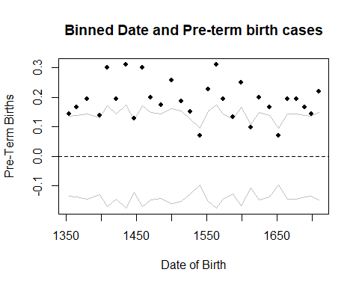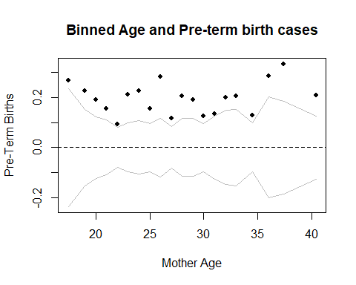

binnedplot(births$mht, y=births$gestation, xlab = "Mother Height", ylab = "Pre-Term Births", main = "Binned Height and Pre-term birth cases")

binnedplot(births$mpregwt, y=births$gestation, xlab = "Mother Weight", ylab = "Pre-Term Births", main = "Binned Weight and Pre-term birth cases")

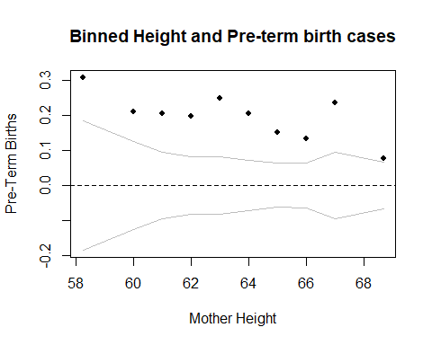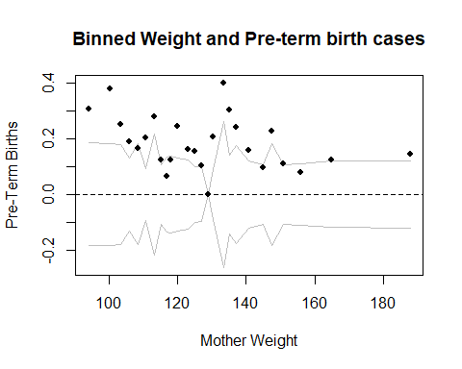

binnedplot(births$date, y=births$gestation, xlab = "Date of Birth", ylab = "Pre-Term Births", main = "Binned Date and Pre-term birth cases")

binnedplot(births$parity, y=births$gestation, xlab = "Parity", ylab = "Pre-Term Births", main = "Binned Parity and Pre-term birth cases")

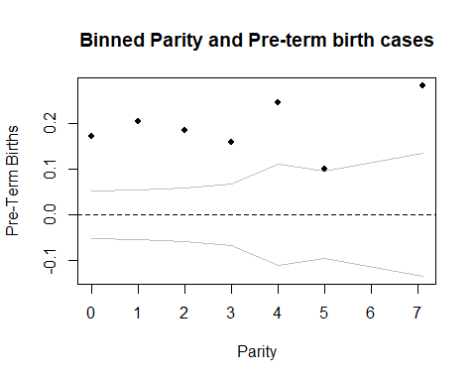

##### Mother’s Age

While pretty evenly distributed, there appears to be a bit of a parabola shape with the younger and older mothers showing more cases.

##### Mothers Height

There don’t appear to be any strong patterns with Mother’s height, but potentially a negative linear trend.

##### Mother’s Pregnant Weight

There are some odd patterns in Mother’s weight, which may be due to sample size within the bins.

##### Date of Birth

There doesn’t seem to be much of any pattern with date of birth, and science knowlege probably notes this as a less relevant predictor.

##### Parity

There are not a lot of bins, but there appears to potentiall be a slight positive linear trend with parity. However it may be worth looking at whether or not there is multicollarity between parity and mothers age.However I did this analysis in the last assignment, and results showed that while there is a correlation (.52), it is not high enough to remove parity from the model.

### Initial Modeling

## take previous analyis model and tweak for new data question  
PTMod1 = glm(gestation ~ mageCent + mhtCent+ mpregwtCent + dateCent+ parityCent + relevel(as.factor(medtxt), ref = "HS Grad Only")+ relevel(as.factor(inctxt), ref="10000-12499") + relevel(as.factor(smoke), ref="0") * relevel(as.factor(mracetxt), ref="White"), data = births, family=binomial)  
   
#summary(PTMod1)  
roc(births$gestation, fitted(PTMod1), plot=T, legacy.axes=T)

##   
## Call:  
## roc.default(response = births$gestation, predictor = fitted(PTMod1), plot = T, legacy.axes = T)  
##   
## Data: fitted(PTMod1) in 705 controls (births$gestation 0) < 164 cases (births$gestation 1).  
## Area under the curve: 0.6784

### AOC = .6784

##add interaction between income and race  
PTMod2 = glm(gestation ~ mageCent + mhtCent+mpregwtCent + dateCent+ parityCent + relevel(as.factor(medtxt), ref = "HS Grad Only")+ relevel(as.factor(smoke), ref="0")+ relevel(as.factor(inctxt), ref="10000-12499")*relevel(as.factor(mracetxt), ref="White") , data = births, family=binomial)  
#summary(PTMod2)  
roc(births$gestation, fitted(PTMod2), plot=T, legacy.axes=T)

##   
## Call:  
## roc.default(response = births$gestation, predictor = fitted(PTMod2), plot = T, legacy.axes = T)  
##   
## Data: fitted(PTMod2) in 705 controls (births$gestation 0) < 164 cases (births$gestation 1).  
## Area under the curve: 0.7165

## AUC = 0.7165

## tried a boolean for education, but didn't add much, actually made worse.so keep as levels. (AOC =.6863)  
births$medbool[births$med == 0] <- 0  
births$medbool[births$med > 0] <- 1  
  
PTMod3 = glm(gestation ~ mageCent + mhtCent + mpregwtCent + dateCent+ parityCent + relevel(as.factor(medbool), ref = 1)+ relevel(as.factor(inctxt), ref="10000-12499")*relevel(as.factor(mracetxt), ref="White") + relevel(as.factor(smoke), ref="0") * relevel(as.factor(mracetxt), ref="White"), data = births, family=binomial)  
   
#summary(PTMod3)  
roc(births$gestation, fitted(PTMod3), plot=T, legacy.axes=T)

##   
## Call:  
## roc.default(response = births$gestation, predictor = fitted(PTMod3), plot = T, legacy.axes = T)  
##   
## Data: fitted(PTMod3) in 705 controls (births$gestation 0) < 164 cases (births$gestation 1).  
## Area under the curve: 0.6863

### AOC = .6863

#Looked at queadratic for preg weight and mage, only weight really helped. So, I also looked at log of preg weight , all with little result. To keep interpretation as simple as possible, will leave these features out.  
  
births$mpregwtCent2 <- births$mpregwtCent^2  
PTMod4 = glm(gestation ~ mageCent + mpregwtCent + mpregwtCent2 + mhtCent +dateCent+ parityCent + relevel(as.factor(medtxt), ref = "HS Grad Only")+ relevel(as.factor(inctxt), ref="10000-12499")*relevel(as.factor(mracetxt), ref="White") + relevel(as.factor(smoke), ref="0") * relevel(as.factor(mracetxt), ref="White"), data = births, family=binomial)  
  
#summary(PTMod4)  
roc(births$gestation, fitted(PTMod4), plot=T, legacy.axes=T)

##   
## Call:  
## roc.default(response = births$gestation, predictor = fitted(PTMod4), plot = T, legacy.axes = T)  
##   
## Data: fitted(PTMod4) in 705 controls (births$gestation 0) < 164 cases (births$gestation 1).  
## Area under the curve: 0.7178

## AUC = 0.7178

#However, another idea was to categorize age, and then look at interactions with mother age and race  
births$magecat[births$mage > 34] <- "Advanced Age Pregnancy"  
births$magecat[births$mage <= 34] <- "'Healthy'Child Bearing Age Pregnancy"  
births$magecat[births$mage < 20] <- "Teen Pregnancy"  
  
PTMod5 = glm(gestation ~ relevel(as.factor(magecat), ref= "'Healthy'Child Bearing Age Pregnancy") + mhtCent+mpregwtCent + dateCent+ parityCent + relevel(as.factor(medtxt), ref = "HS Grad Only")+ relevel(as.factor(smoke), ref="0")+ relevel(as.factor(inctxt), ref="10000-12499")*relevel(as.factor(mracetxt), ref="White")+ relevel(as.factor(magecat), ref= "'Healthy'Child Bearing Age Pregnancy")*relevel(as.factor(mracetxt), ref="White") , data = births, family=binomial)  
#summary(PTMod5)  
roc(births$gestation, fitted(PTMod5), plot=T, legacy.axes=T)

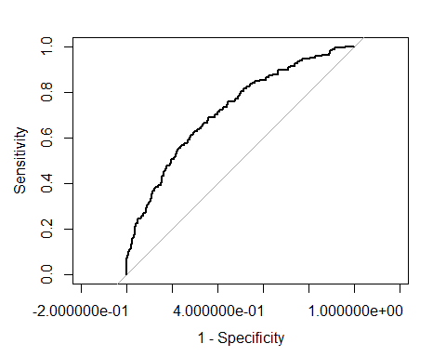

##   
## Call:  
## roc.default(response = births$gestation, predictor = fitted(PTMod5), plot = T, legacy.axes = T)  
##   
## Data: fitted(PTMod5) in 705 controls (births$gestation 0) < 164 cases (births$gestation 1).  
## Area under the curve: 0.7205

# AUC = 0.7205

After considering inital plots and a few initial models, I settled on this last model to run diagnostics on because it makes the most sense considering science, interprebility, and area under the curve.

### Model 5

Baseline Predictor Factors: Smoker= Non Smoker, Race= White Mother, Mother Age = ‘Healthy’ Child Bearing Age Pregnancy Mother Education = HS Grad Only, Income = $10,000 - $12,499

Model Variables: Mother Height (centered), Mother Pregnant Weight (centered), Parity (centered), Date of Birth (centered)

Interactions: Mother Race(As Factor, White) * Mother Income(as Factor, $10000-$12499)

(see end of document for model output for Model 2, as this was the model I settled on)

#### Model 5 Residuals

The residuals for this model look pretty good. The binned plots look evenly distributed, and the mean tables comparing residuals to each of the categorical variables have very low numbers.

rawresid1 = births$gestation - fitted(PTMod5)  
  
  
binnedplot(x=births$parityCent, y = rawresid1, xlab = "Parity Centered", ylab = "Residuals", main = "Binned residuals versus Parity Centered")

binnedplot(x=births$mhtCent, y = rawresid1, xlab = "Mother Height Centered", ylab = "Residuals", main = "Binned residuals versus Mother Height Centered")

binnedplot(x=births$dateCent, y = rawresid1, xlab = "Date of Birth Centered", ylab = "Residuals", main = "Binned residuals versus Date of Birth Centered")

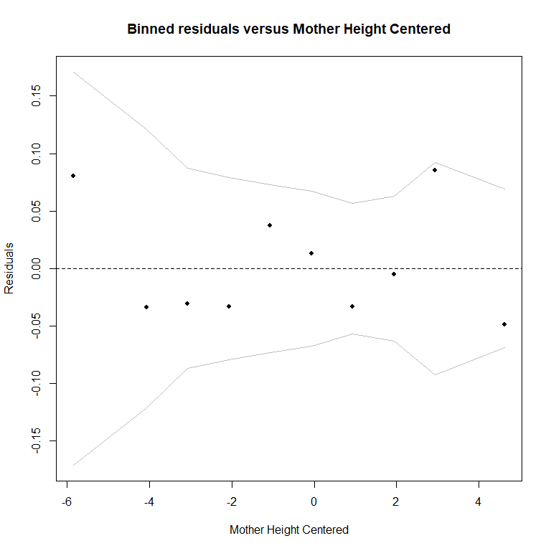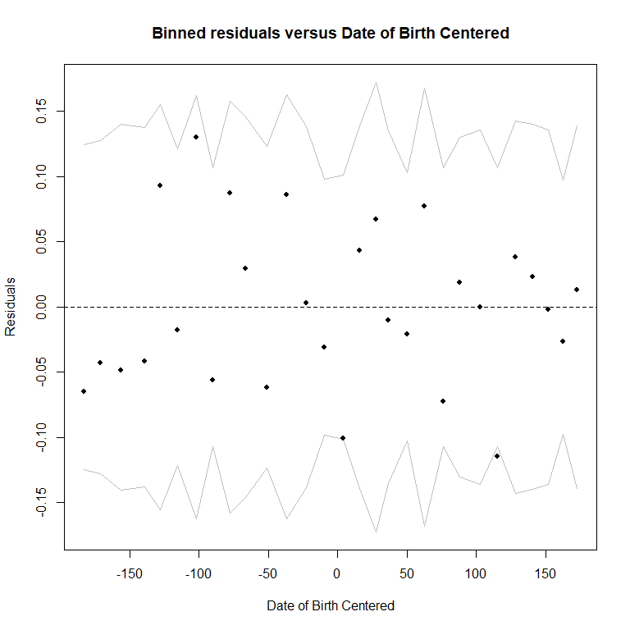binnedplot(x=births$mpregwtCent, y = rawresid1, xlab = "Mother Preg Weight Centered", ylab = "Residuals", main = "Binned residuals versus Mother Preg Weight Centered")

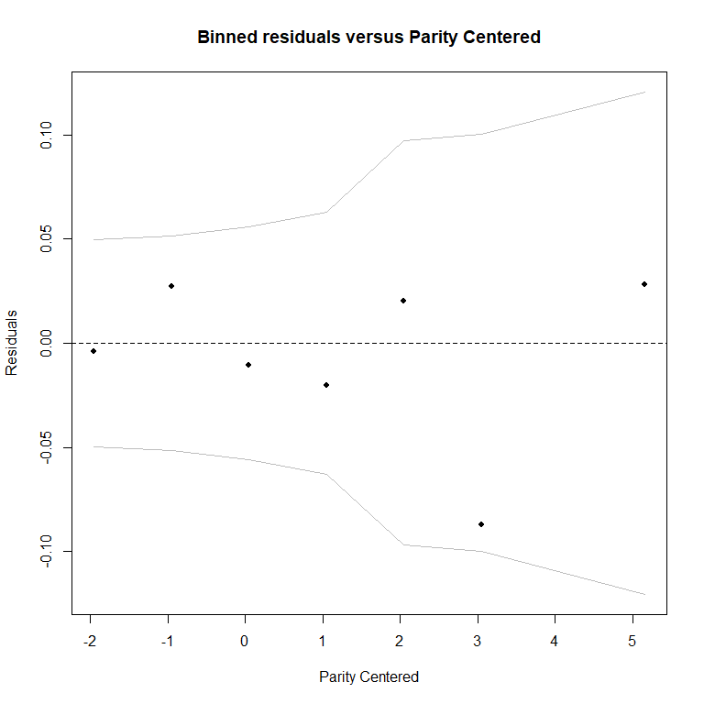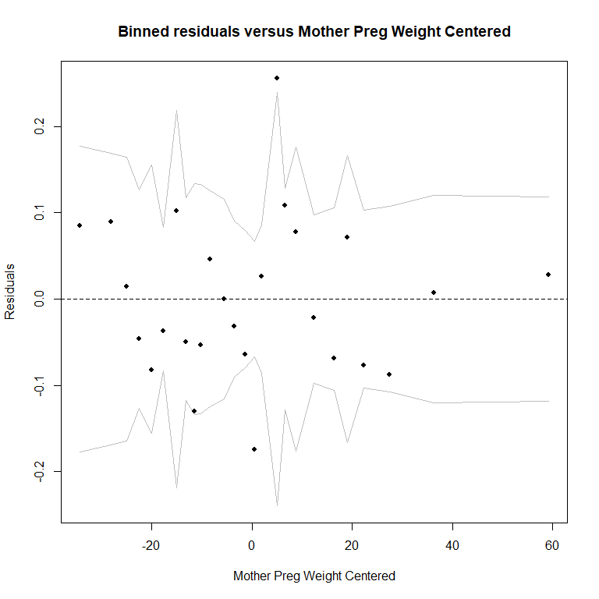

tapply(rawresid1, births$medtxt, mean)

## 8th to 12th, No Grad College Grad   
## -3.173544e-09 -1.060624e-09   
## HS Grad and Trade HS Grad Only   
## -3.909400e-09 -1.333460e-09   
## HS Grade and Some College Less than 8th Grade   
## -1.813702e-09 8.826327e-16   
## Trade School (HSG Unknown)   
## -1.498801e-15

tapply(rawresid1, births$magecat, mean)

## 'Healthy'Child Bearing Age Pregnancy Advanced Age Pregnancy   
## -1.721783e-09 -2.986141e-09   
## Teen Pregnancy   
## 2.737363e-16

tapply(rawresid1, births$inctxt, mean)

## 10000-12499 12500-14999 15000-17499 17500-19999 20000-22499   
## -6.084967e-10 -1.305926e-09 -2.304357e-09 -8.376975e-10 -1.201185e-08   
## 22500+ 2500-4999 5000-7499 7500-9999 Under 2500   
## 1.090294e-16 2.866441e-16 -4.652280e-09 -2.011294e-09 -2.748244e-17

tapply(rawresid1, births$mracetxt,mean)

## Asian Black Mexican Mix White   
## -9.965037e-09 -1.137216e-09 -6.427102e-09 -5.796572e-08 2.664891e-16

tapply(rawresid1, births$smoke, mean)

## 0 1   
## -3.076650e-09 -3.162407e-10

#let's do the confusion matrix  
  
threshold = 0.5  
table(births$gestation, PTMod5$fitted > threshold)

##   
## FALSE TRUE  
## 0 695 10  
## 1 146 18

threshold = 0.58  
table(births$gestation, PTMod5$fitted > threshold)

##   
## FALSE TRUE  
## 0 703 2  
## 1 151 13

After these additional explorations, the best area under the curve I was able to achieve while also feeling interpretable was 0.7205 and I feel good moving on to interpreting my selected model.

## Final Model Interpretation

The Final Model I selected is as follows:

PTMod5 = glm(gestation ~ relevel(as.factor(magecat), ref= "'Healthy'Child Bearing Age Pregnancy") + mhtCent+mpregwtCent + dateCent+ parityCent + relevel(as.factor(medtxt), ref = "HS Grad Only")+ relevel(as.factor(smoke), ref="0")+ relevel(as.factor(inctxt), ref="10000-12499")*relevel(as.factor(mracetxt), ref="White")+ relevel(as.factor(magecat), ref= "'Healthy'Child Bearing Age Pregnancy")*relevel(as.factor(mracetxt), ref="White") , data = births, family=binomial)  
summary(PTMod5)

##   
## Call:  
## glm(formula = gestation ~ relevel(as.factor(magecat), ref = "'Healthy'Child Bearing Age Pregnancy") +   
## mhtCent + mpregwtCent + dateCent + parityCent + relevel(as.factor(medtxt),   
## ref = "HS Grad Only") + relevel(as.factor(smoke), ref = "0") +   
## relevel(as.factor(inctxt), ref = "10000-12499") * relevel(as.factor(mracetxt),   
## ref = "White") + relevel(as.factor(magecat), ref = "'Healthy'Child Bearing Age Pregnancy") *   
## relevel(as.factor(mracetxt), ref = "White"), family = binomial,   
## data = births)  
##   
## Deviance Residuals:   
## Min 1Q Median 3Q Max   
## -1.4369 -0.6615 -0.5028 -0.3148 2.6863   
##   
## Coefficients: (8 not defined because of singularities)  
## Estimate  
## (Intercept) -1.655e+00  
## relevel(as.factor(magecat), ref = "'Healthy'Child Bearing Age Pregnancy")Advanced Age Pregnancy 4.887e-01  
## relevel(as.factor(magecat), ref = "'Healthy'Child Bearing Age Pregnancy")Teen Pregnancy -2.978e-01  
## mhtCent -2.908e-02  
## mpregwtCent -1.357e-02  
## dateCent -1.079e-03  
## parityCent 2.277e-02  
## relevel(as.factor(medtxt), ref = "HS Grad Only")8th to 12th, No Grad 3.819e-01  
## relevel(as.factor(medtxt), ref = "HS Grad Only")College Grad -2.802e-01  
## relevel(as.factor(medtxt), ref = "HS Grad Only")HS Grad and Trade -1.757e-02  
## relevel(as.factor(medtxt), ref = "HS Grad Only")HS Grade and Some College -7.727e-01  
## relevel(as.factor(medtxt), ref = "HS Grad Only")Less than 8th Grade 8.456e-01  
## relevel(as.factor(medtxt), ref = "HS Grad Only")Trade School (HSG Unknown) 3.148e+00  
## relevel(as.factor(smoke), ref = "0")1 2.287e-01  
## relevel(as.factor(inctxt), ref = "10000-12499")12500-14999 2.655e-01  
## relevel(as.factor(inctxt), ref = "10000-12499")15000-17499 -1.662e-02  
## relevel(as.factor(inctxt), ref = "10000-12499")17500-19999 -4.730e-01  
## relevel(as.factor(inctxt), ref = "10000-12499")20000-22499 -8.535e-01  
## relevel(as.factor(inctxt), ref = "10000-12499")22500+ -5.240e-02  
## relevel(as.factor(inctxt), ref = "10000-12499")2500-4999 1.725e-01  
## relevel(as.factor(inctxt), ref = "10000-12499")5000-7499 -5.156e-01  
## relevel(as.factor(inctxt), ref = "10000-12499")7500-9999 -5.748e-02  
## relevel(as.factor(inctxt), ref = "10000-12499")Under 2500 -3.596e-01  
## relevel(as.factor(mracetxt), ref = "White")Asian 1.440e+00  
## relevel(as.factor(mracetxt), ref = "White")Black 2.325e-01  
## relevel(as.factor(mracetxt), ref = "White")Mexican 1.662e+00  
## relevel(as.factor(mracetxt), ref = "White")Mix -1.371e+01  
## relevel(as.factor(inctxt), ref = "10000-12499")12500-14999:relevel(as.factor(mracetxt), ref = "White")Asian -4.234e-01  
## relevel(as.factor(inctxt), ref = "10000-12499")15000-17499:relevel(as.factor(mracetxt), ref = "White")Asian -1.622e+01  
## relevel(as.factor(inctxt), ref = "10000-12499")17500-19999:relevel(as.factor(mracetxt), ref = "White")Asian 1.094e-01  
## relevel(as.factor(inctxt), ref = "10000-12499")20000-22499:relevel(as.factor(mracetxt), ref = "White")Asian NA  
## relevel(as.factor(inctxt), ref = "10000-12499")22500+:relevel(as.factor(mracetxt), ref = "White")Asian 1.682e+01  
## relevel(as.factor(inctxt), ref = "10000-12499")2500-4999:relevel(as.factor(mracetxt), ref = "White")Asian -1.486e+00  
## relevel(as.factor(inctxt), ref = "10000-12499")5000-7499:relevel(as.factor(mracetxt), ref = "White")Asian -1.627e+01  
## relevel(as.factor(inctxt), ref = "10000-12499")7500-9999:relevel(as.factor(mracetxt), ref = "White")Asian -4.221e-01  
## relevel(as.factor(inctxt), ref = "10000-12499")Under 2500:relevel(as.factor(mracetxt), ref = "White")Asian 6.342e-01  
## relevel(as.factor(inctxt), ref = "10000-12499")12500-14999:relevel(as.factor(mracetxt), ref = "White")Black -6.256e-01  
## relevel(as.factor(inctxt), ref = "10000-12499")15000-17499:relevel(as.factor(mracetxt), ref = "White")Black 7.168e-01  
## relevel(as.factor(inctxt), ref = "10000-12499")17500-19999:relevel(as.factor(mracetxt), ref = "White")Black 2.156e+00  
## relevel(as.factor(inctxt), ref = "10000-12499")20000-22499:relevel(as.factor(mracetxt), ref = "White")Black -1.416e+01  
## relevel(as.factor(inctxt), ref = "10000-12499")22500+:relevel(as.factor(mracetxt), ref = "White")Black -1.461e+01  
## relevel(as.factor(inctxt), ref = "10000-12499")2500-4999:relevel(as.factor(mracetxt), ref = "White")Black -1.939e-01  
## relevel(as.factor(inctxt), ref = "10000-12499")5000-7499:relevel(as.factor(mracetxt), ref = "White")Black 1.335e+00  
## relevel(as.factor(inctxt), ref = "10000-12499")7500-9999:relevel(as.factor(mracetxt), ref = "White")Black 8.622e-01  
## relevel(as.factor(inctxt), ref = "10000-12499")Under 2500:relevel(as.factor(mracetxt), ref = "White")Black 1.738e+00  
## relevel(as.factor(inctxt), ref = "10000-12499")12500-14999:relevel(as.factor(mracetxt), ref = "White")Mexican -1.362e+00  
## relevel(as.factor(inctxt), ref = "10000-12499")15000-17499:relevel(as.factor(mracetxt), ref = "White")Mexican 1.660e+01  
## relevel(as.factor(inctxt), ref = "10000-12499")17500-19999:relevel(as.factor(mracetxt), ref = "White")Mexican -1.726e+01  
## relevel(as.factor(inctxt), ref = "10000-12499")20000-22499:relevel(as.factor(mracetxt), ref = "White")Mexican NA  
## relevel(as.factor(inctxt), ref = "10000-12499")22500+:relevel(as.factor(mracetxt), ref = "White")Mexican NA  
## relevel(as.factor(inctxt), ref = "10000-12499")2500-4999:relevel(as.factor(mracetxt), ref = "White")Mexican -3.620e+00  
## relevel(as.factor(inctxt), ref = "10000-12499")5000-7499:relevel(as.factor(mracetxt), ref = "White")Mexican -1.691e+01  
## relevel(as.factor(inctxt), ref = "10000-12499")7500-9999:relevel(as.factor(mracetxt), ref = "White")Mexican -2.769e+00  
## relevel(as.factor(inctxt), ref = "10000-12499")Under 2500:relevel(as.factor(mracetxt), ref = "White")Mexican NA  
## relevel(as.factor(inctxt), ref = "10000-12499")12500-14999:relevel(as.factor(mracetxt), ref = "White")Mix -6.654e-01  
## relevel(as.factor(inctxt), ref = "10000-12499")15000-17499:relevel(as.factor(mracetxt), ref = "White")Mix -8.520e-01  
## relevel(as.factor(inctxt), ref = "10000-12499")17500-19999:relevel(as.factor(mracetxt), ref = "White")Mix 3.266e+01  
## relevel(as.factor(inctxt), ref = "10000-12499")20000-22499:relevel(as.factor(mracetxt), ref = "White")Mix 7.733e-01  
## relevel(as.factor(inctxt), ref = "10000-12499")22500+:relevel(as.factor(mracetxt), ref = "White")Mix NA  
## relevel(as.factor(inctxt), ref = "10000-12499")2500-4999:relevel(as.factor(mracetxt), ref = "White")Mix -1.055e+00  
## relevel(as.factor(inctxt), ref = "10000-12499")5000-7499:relevel(as.factor(mracetxt), ref = "White")Mix -8.412e-01  
## relevel(as.factor(inctxt), ref = "10000-12499")7500-9999:relevel(as.factor(mracetxt), ref = "White")Mix -1.089e+00  
## relevel(as.factor(inctxt), ref = "10000-12499")Under 2500:relevel(as.factor(mracetxt), ref = "White")Mix NA  
## relevel(as.factor(magecat), ref = "'Healthy'Child Bearing Age Pregnancy")Advanced Age Pregnancy:relevel(as.factor(mracetxt), ref = "White")Asian -6.157e-01  
## relevel(as.factor(magecat), ref = "'Healthy'Child Bearing Age Pregnancy")Teen Pregnancy:relevel(as.factor(mracetxt), ref = "White")Asian NA  
## relevel(as.factor(magecat), ref = "'Healthy'Child Bearing Age Pregnancy")Advanced Age Pregnancy:relevel(as.factor(mracetxt), ref = "White")Black -7.675e-01  
## relevel(as.factor(magecat), ref = "'Healthy'Child Bearing Age Pregnancy")Teen Pregnancy:relevel(as.factor(mracetxt), ref = "White")Black 6.857e-01  
## relevel(as.factor(magecat), ref = "'Healthy'Child Bearing Age Pregnancy")Advanced Age Pregnancy:relevel(as.factor(mracetxt), ref = "White")Mexican 1.215e+00  
## relevel(as.factor(magecat), ref = "'Healthy'Child Bearing Age Pregnancy")Teen Pregnancy:relevel(as.factor(mracetxt), ref = "White")Mexican 1.930e+01  
## relevel(as.factor(magecat), ref = "'Healthy'Child Bearing Age Pregnancy")Advanced Age Pregnancy:relevel(as.factor(mracetxt), ref = "White")Mix -8.509e-01  
## relevel(as.factor(magecat), ref = "'Healthy'Child Bearing Age Pregnancy")Teen Pregnancy:relevel(as.factor(mracetxt), ref = "White")Mix NA  
## Std. Error  
## (Intercept) 3.418e-01  
## relevel(as.factor(magecat), ref = "'Healthy'Child Bearing Age Pregnancy")Advanced Age Pregnancy 3.443e-01  
## relevel(as.factor(magecat), ref = "'Healthy'Child Bearing Age Pregnancy")Teen Pregnancy 5.226e-01  
## mhtCent 4.471e-02  
## mpregwtCent 5.819e-03  
## dateCent 9.023e-04  
## parityCent 5.898e-02  
## relevel(as.factor(medtxt), ref = "HS Grad Only")8th to 12th, No Grad 2.867e-01  
## relevel(as.factor(medtxt), ref = "HS Grad Only")College Grad 2.956e-01  
## relevel(as.factor(medtxt), ref = "HS Grad Only")HS Grad and Trade 4.043e-01  
## relevel(as.factor(medtxt), ref = "HS Grad Only")HS Grade and Some College 2.857e-01  
## relevel(as.factor(medtxt), ref = "HS Grad Only")Less than 8th Grade 1.062e+00  
## relevel(as.factor(medtxt), ref = "HS Grad Only")Trade School (HSG Unknown) 1.374e+00  
## relevel(as.factor(smoke), ref = "0")1 1.987e-01  
## relevel(as.factor(inctxt), ref = "10000-12499")12500-14999 4.163e-01  
## relevel(as.factor(inctxt), ref = "10000-12499")15000-17499 5.220e-01  
## relevel(as.factor(inctxt), ref = "10000-12499")17500-19999 4.583e-01  
## relevel(as.factor(inctxt), ref = "10000-12499")20000-22499 1.107e+00  
## relevel(as.factor(inctxt), ref = "10000-12499")22500+ 7.290e-01  
## relevel(as.factor(inctxt), ref = "10000-12499")2500-4999 4.178e-01  
## relevel(as.factor(inctxt), ref = "10000-12499")5000-7499 4.398e-01  
## relevel(as.factor(inctxt), ref = "10000-12499")7500-9999 4.066e-01  
## relevel(as.factor(inctxt), ref = "10000-12499")Under 2500 8.538e-01  
## relevel(as.factor(mracetxt), ref = "White")Asian 1.132e+00  
## relevel(as.factor(mracetxt), ref = "White")Black 7.584e-01  
## relevel(as.factor(mracetxt), ref = "White")Mexican 1.459e+00  
## relevel(as.factor(mracetxt), ref = "White")Mix 2.400e+03  
## relevel(as.factor(inctxt), ref = "10000-12499")12500-14999:relevel(as.factor(mracetxt), ref = "White")Asian 1.839e+00  
## relevel(as.factor(inctxt), ref = "10000-12499")15000-17499:relevel(as.factor(mracetxt), ref = "White")Asian 1.674e+03  
## relevel(as.factor(inctxt), ref = "10000-12499")17500-19999:relevel(as.factor(mracetxt), ref = "White")Asian 1.315e+00  
## relevel(as.factor(inctxt), ref = "10000-12499")20000-22499:relevel(as.factor(mracetxt), ref = "White")Asian NA  
## relevel(as.factor(inctxt), ref = "10000-12499")22500+:relevel(as.factor(mracetxt), ref = "White")Asian 2.400e+03  
## relevel(as.factor(inctxt), ref = "10000-12499")2500-4999:relevel(as.factor(mracetxt), ref = "White")Asian 1.601e+00  
## relevel(as.factor(inctxt), ref = "10000-12499")5000-7499:relevel(as.factor(mracetxt), ref = "White")Asian 1.164e+03  
## relevel(as.factor(inctxt), ref = "10000-12499")7500-9999:relevel(as.factor(mracetxt), ref = "White")Asian 1.711e+00  
## relevel(as.factor(inctxt), ref = "10000-12499")Under 2500:relevel(as.factor(mracetxt), ref = "White")Asian 1.970e+00  
## relevel(as.factor(inctxt), ref = "10000-12499")12500-14999:relevel(as.factor(mracetxt), ref = "White")Black 1.130e+00  
## relevel(as.factor(inctxt), ref = "10000-12499")15000-17499:relevel(as.factor(mracetxt), ref = "White")Black 1.110e+00  
## relevel(as.factor(inctxt), ref = "10000-12499")17500-19999:relevel(as.factor(mracetxt), ref = "White")Black 1.018e+00  
## relevel(as.factor(inctxt), ref = "10000-12499")20000-22499:relevel(as.factor(mracetxt), ref = "White")Black 1.693e+03  
## relevel(as.factor(inctxt), ref = "10000-12499")22500+:relevel(as.factor(mracetxt), ref = "White")Black 2.400e+03  
## relevel(as.factor(inctxt), ref = "10000-12499")2500-4999:relevel(as.factor(mracetxt), ref = "White")Black 8.796e-01  
## relevel(as.factor(inctxt), ref = "10000-12499")5000-7499:relevel(as.factor(mracetxt), ref = "White")Black 8.895e-01  
## relevel(as.factor(inctxt), ref = "10000-12499")7500-9999:relevel(as.factor(mracetxt), ref = "White")Black 9.632e-01  
## relevel(as.factor(inctxt), ref = "10000-12499")Under 2500:relevel(as.factor(mracetxt), ref = "White")Black 1.323e+00  
## relevel(as.factor(inctxt), ref = "10000-12499")12500-14999:relevel(as.factor(mracetxt), ref = "White")Mexican 1.878e+00  
## relevel(as.factor(inctxt), ref = "10000-12499")15000-17499:relevel(as.factor(mracetxt), ref = "White")Mexican 2.400e+03  
## relevel(as.factor(inctxt), ref = "10000-12499")17500-19999:relevel(as.factor(mracetxt), ref = "White")Mexican 1.531e+03  
## relevel(as.factor(inctxt), ref = "10000-12499")20000-22499:relevel(as.factor(mracetxt), ref = "White")Mexican NA  
## relevel(as.factor(inctxt), ref = "10000-12499")22500+:relevel(as.factor(mracetxt), ref = "White")Mexican NA  
## relevel(as.factor(inctxt), ref = "10000-12499")2500-4999:relevel(as.factor(mracetxt), ref = "White")Mexican 2.023e+00  
## relevel(as.factor(inctxt), ref = "10000-12499")5000-7499:relevel(as.factor(mracetxt), ref = "White")Mexican 1.672e+03  
## relevel(as.factor(inctxt), ref = "10000-12499")7500-9999:relevel(as.factor(mracetxt), ref = "White")Mexican 2.427e+00  
## relevel(as.factor(inctxt), ref = "10000-12499")Under 2500:relevel(as.factor(mracetxt), ref = "White")Mexican NA  
## relevel(as.factor(inctxt), ref = "10000-12499")12500-14999:relevel(as.factor(mracetxt), ref = "White")Mix 2.938e+03  
## relevel(as.factor(inctxt), ref = "10000-12499")15000-17499:relevel(as.factor(mracetxt), ref = "White")Mix 3.393e+03  
## relevel(as.factor(inctxt), ref = "10000-12499")17500-19999:relevel(as.factor(mracetxt), ref = "White")Mix 3.393e+03  
## relevel(as.factor(inctxt), ref = "10000-12499")20000-22499:relevel(as.factor(mracetxt), ref = "White")Mix 4.362e+03  
## relevel(as.factor(inctxt), ref = "10000-12499")22500+:relevel(as.factor(mracetxt), ref = "White")Mix NA  
## relevel(as.factor(inctxt), ref = "10000-12499")2500-4999:relevel(as.factor(mracetxt), ref = "White")Mix 3.393e+03  
## relevel(as.factor(inctxt), ref = "10000-12499")5000-7499:relevel(as.factor(mracetxt), ref = "White")Mix 2.663e+03  
## relevel(as.factor(inctxt), ref = "10000-12499")7500-9999:relevel(as.factor(mracetxt), ref = "White")Mix 2.741e+03  
## relevel(as.factor(inctxt), ref = "10000-12499")Under 2500:relevel(as.factor(mracetxt), ref = "White")Mix NA  
## relevel(as.factor(magecat), ref = "'Healthy'Child Bearing Age Pregnancy")Advanced Age Pregnancy:relevel(as.factor(mracetxt), ref = "White")Asian 1.368e+00  
## relevel(as.factor(magecat), ref = "'Healthy'Child Bearing Age Pregnancy")Teen Pregnancy:relevel(as.factor(mracetxt), ref = "White")Asian NA  
## relevel(as.factor(magecat), ref = "'Healthy'Child Bearing Age Pregnancy")Advanced Age Pregnancy:relevel(as.factor(mracetxt), ref = "White")Black 6.430e-01  
## relevel(as.factor(magecat), ref = "'Healthy'Child Bearing Age Pregnancy")Teen Pregnancy:relevel(as.factor(mracetxt), ref = "White")Black 9.138e-01  
## relevel(as.factor(magecat), ref = "'Healthy'Child Bearing Age Pregnancy")Advanced Age Pregnancy:relevel(as.factor(mracetxt), ref = "White")Mexican 2.089e+00  
## relevel(as.factor(magecat), ref = "'Healthy'Child Bearing Age Pregnancy")Teen Pregnancy:relevel(as.factor(mracetxt), ref = "White")Mexican 2.400e+03  
## relevel(as.factor(magecat), ref = "'Healthy'Child Bearing Age Pregnancy")Advanced Age Pregnancy:relevel(as.factor(mracetxt), ref = "White")Mix 2.741e+03  
## relevel(as.factor(magecat), ref = "'Healthy'Child Bearing Age Pregnancy")Teen Pregnancy:relevel(as.factor(mracetxt), ref = "White")Mix NA  
## z value  
## (Intercept) -4.841  
## relevel(as.factor(magecat), ref = "'Healthy'Child Bearing Age Pregnancy")Advanced Age Pregnancy 1.419  
## relevel(as.factor(magecat), ref = "'Healthy'Child Bearing Age Pregnancy")Teen Pregnancy -0.570  
## mhtCent -0.650  
## mpregwtCent -2.333  
## dateCent -1.196  
## parityCent 0.386  
## relevel(as.factor(medtxt), ref = "HS Grad Only")8th to 12th, No Grad 1.332  
## relevel(as.factor(medtxt), ref = "HS Grad Only")College Grad -0.948  
## relevel(as.factor(medtxt), ref = "HS Grad Only")HS Grad and Trade -0.043  
## relevel(as.factor(medtxt), ref = "HS Grad Only")HS Grade and Some College -2.705  
## relevel(as.factor(medtxt), ref = "HS Grad Only")Less than 8th Grade 0.797  
## relevel(as.factor(medtxt), ref = "HS Grad Only")Trade School (HSG Unknown) 2.291  
## relevel(as.factor(smoke), ref = "0")1 1.151  
## relevel(as.factor(inctxt), ref = "10000-12499")12500-14999 0.638  
## relevel(as.factor(inctxt), ref = "10000-12499")15000-17499 -0.032  
## relevel(as.factor(inctxt), ref = "10000-12499")17500-19999 -1.032  
## relevel(as.factor(inctxt), ref = "10000-12499")20000-22499 -0.771  
## relevel(as.factor(inctxt), ref = "10000-12499")22500+ -0.072  
## relevel(as.factor(inctxt), ref = "10000-12499")2500-4999 0.413  
## relevel(as.factor(inctxt), ref = "10000-12499")5000-7499 -1.172  
## relevel(as.factor(inctxt), ref = "10000-12499")7500-9999 -0.141  
## relevel(as.factor(inctxt), ref = "10000-12499")Under 2500 -0.421  
## relevel(as.factor(mracetxt), ref = "White")Asian 1.272  
## relevel(as.factor(mracetxt), ref = "White")Black 0.307  
## relevel(as.factor(mracetxt), ref = "White")Mexican 1.139  
## relevel(as.factor(mracetxt), ref = "White")Mix -0.006  
## relevel(as.factor(inctxt), ref = "10000-12499")12500-14999:relevel(as.factor(mracetxt), ref = "White")Asian -0.230  
## relevel(as.factor(inctxt), ref = "10000-12499")15000-17499:relevel(as.factor(mracetxt), ref = "White")Asian -0.010  
## relevel(as.factor(inctxt), ref = "10000-12499")17500-19999:relevel(as.factor(mracetxt), ref = "White")Asian 0.083  
## relevel(as.factor(inctxt), ref = "10000-12499")20000-22499:relevel(as.factor(mracetxt), ref = "White")Asian NA  
## relevel(as.factor(inctxt), ref = "10000-12499")22500+:relevel(as.factor(mracetxt), ref = "White")Asian 0.007  
## relevel(as.factor(inctxt), ref = "10000-12499")2500-4999:relevel(as.factor(mracetxt), ref = "White")Asian -0.928  
## relevel(as.factor(inctxt), ref = "10000-12499")5000-7499:relevel(as.factor(mracetxt), ref = "White")Asian -0.014  
## relevel(as.factor(inctxt), ref = "10000-12499")7500-9999:relevel(as.factor(mracetxt), ref = "White")Asian -0.247  
## relevel(as.factor(inctxt), ref = "10000-12499")Under 2500:relevel(as.factor(mracetxt), ref = "White")Asian 0.322  
## relevel(as.factor(inctxt), ref = "10000-12499")12500-14999:relevel(as.factor(mracetxt), ref = "White")Black -0.554  
## relevel(as.factor(inctxt), ref = "10000-12499")15000-17499:relevel(as.factor(mracetxt), ref = "White")Black 0.646  
## relevel(as.factor(inctxt), ref = "10000-12499")17500-19999:relevel(as.factor(mracetxt), ref = "White")Black 2.118  
## relevel(as.factor(inctxt), ref = "10000-12499")20000-22499:relevel(as.factor(mracetxt), ref = "White")Black -0.008  
## relevel(as.factor(inctxt), ref = "10000-12499")22500+:relevel(as.factor(mracetxt), ref = "White")Black -0.006  
## relevel(as.factor(inctxt), ref = "10000-12499")2500-4999:relevel(as.factor(mracetxt), ref = "White")Black -0.220  
## relevel(as.factor(inctxt), ref = "10000-12499")5000-7499:relevel(as.factor(mracetxt), ref = "White")Black 1.501  
## relevel(as.factor(inctxt), ref = "10000-12499")7500-9999:relevel(as.factor(mracetxt), ref = "White")Black 0.895  
## relevel(as.factor(inctxt), ref = "10000-12499")Under 2500:relevel(as.factor(mracetxt), ref = "White")Black 1.314  
## relevel(as.factor(inctxt), ref = "10000-12499")12500-14999:relevel(as.factor(mracetxt), ref = "White")Mexican -0.725  
## relevel(as.factor(inctxt), ref = "10000-12499")15000-17499:relevel(as.factor(mracetxt), ref = "White")Mexican 0.007  
## relevel(as.factor(inctxt), ref = "10000-12499")17500-19999:relevel(as.factor(mracetxt), ref = "White")Mexican -0.011  
## relevel(as.factor(inctxt), ref = "10000-12499")20000-22499:relevel(as.factor(mracetxt), ref = "White")Mexican NA  
## relevel(as.factor(inctxt), ref = "10000-12499")22500+:relevel(as.factor(mracetxt), ref = "White")Mexican NA  
## relevel(as.factor(inctxt), ref = "10000-12499")2500-4999:relevel(as.factor(mracetxt), ref = "White")Mexican -1.789  
## relevel(as.factor(inctxt), ref = "10000-12499")5000-7499:relevel(as.factor(mracetxt), ref = "White")Mexican -0.010  
## relevel(as.factor(inctxt), ref = "10000-12499")7500-9999:relevel(as.factor(mracetxt), ref = "White")Mexican -1.141  
## relevel(as.factor(inctxt), ref = "10000-12499")Under 2500:relevel(as.factor(mracetxt), ref = "White")Mexican NA  
## relevel(as.factor(inctxt), ref = "10000-12499")12500-14999:relevel(as.factor(mracetxt), ref = "White")Mix 0.000  
## relevel(as.factor(inctxt), ref = "10000-12499")15000-17499:relevel(as.factor(mracetxt), ref = "White")Mix 0.000  
## relevel(as.factor(inctxt), ref = "10000-12499")17500-19999:relevel(as.factor(mracetxt), ref = "White")Mix 0.010  
## relevel(as.factor(inctxt), ref = "10000-12499")20000-22499:relevel(as.factor(mracetxt), ref = "White")Mix 0.000  
## relevel(as.factor(inctxt), ref = "10000-12499")22500+:relevel(as.factor(mracetxt), ref = "White")Mix NA  
## relevel(as.factor(inctxt), ref = "10000-12499")2500-4999:relevel(as.factor(mracetxt), ref = "White")Mix 0.000  
## relevel(as.factor(inctxt), ref = "10000-12499")5000-7499:relevel(as.factor(mracetxt), ref = "White")Mix 0.000  
## relevel(as.factor(inctxt), ref = "10000-12499")7500-9999:relevel(as.factor(mracetxt), ref = "White")Mix 0.000  
## relevel(as.factor(inctxt), ref = "10000-12499")Under 2500:relevel(as.factor(mracetxt), ref = "White")Mix NA  
## relevel(as.factor(magecat), ref = "'Healthy'Child Bearing Age Pregnancy")Advanced Age Pregnancy:relevel(as.factor(mracetxt), ref = "White")Asian -0.450  
## relevel(as.factor(magecat), ref = "'Healthy'Child Bearing Age Pregnancy")Teen Pregnancy:relevel(as.factor(mracetxt), ref = "White")Asian NA  
## relevel(as.factor(magecat), ref = "'Healthy'Child Bearing Age Pregnancy")Advanced Age Pregnancy:relevel(as.factor(mracetxt), ref = "White")Black -1.194  
## relevel(as.factor(magecat), ref = "'Healthy'Child Bearing Age Pregnancy")Teen Pregnancy:relevel(as.factor(mracetxt), ref = "White")Black 0.750  
## relevel(as.factor(magecat), ref = "'Healthy'Child Bearing Age Pregnancy")Advanced Age Pregnancy:relevel(as.factor(mracetxt), ref = "White")Mexican 0.582  
## relevel(as.factor(magecat), ref = "'Healthy'Child Bearing Age Pregnancy")Teen Pregnancy:relevel(as.factor(mracetxt), ref = "White")Mexican 0.008  
## relevel(as.factor(magecat), ref = "'Healthy'Child Bearing Age Pregnancy")Advanced Age Pregnancy:relevel(as.factor(mracetxt), ref = "White")Mix 0.000  
## relevel(as.factor(magecat), ref = "'Healthy'Child Bearing Age Pregnancy")Teen Pregnancy:relevel(as.factor(mracetxt), ref = "White")Mix NA  
## Pr(>|z|)  
## (Intercept) 1.29e-06  
## relevel(as.factor(magecat), ref = "'Healthy'Child Bearing Age Pregnancy")Advanced Age Pregnancy 0.15582  
## relevel(as.factor(magecat), ref = "'Healthy'Child Bearing Age Pregnancy")Teen Pregnancy 0.56876  
## mhtCent 0.51538  
## mpregwtCent 0.01967  
## dateCent 0.23166  
## parityCent 0.69943  
## relevel(as.factor(medtxt), ref = "HS Grad Only")8th to 12th, No Grad 0.18279  
## relevel(as.factor(medtxt), ref = "HS Grad Only")College Grad 0.34324  
## relevel(as.factor(medtxt), ref = "HS Grad Only")HS Grad and Trade 0.96534  
## relevel(as.factor(medtxt), ref = "HS Grad Only")HS Grade and Some College 0.00684  
## relevel(as.factor(medtxt), ref = "HS Grad Only")Less than 8th Grade 0.42571  
## relevel(as.factor(medtxt), ref = "HS Grad Only")Trade School (HSG Unknown) 0.02199  
## relevel(as.factor(smoke), ref = "0")1 0.24958  
## relevel(as.factor(inctxt), ref = "10000-12499")12500-14999 0.52355  
## relevel(as.factor(inctxt), ref = "10000-12499")15000-17499 0.97460  
## relevel(as.factor(inctxt), ref = "10000-12499")17500-19999 0.30202  
## relevel(as.factor(inctxt), ref = "10000-12499")20000-22499 0.44064  
## relevel(as.factor(inctxt), ref = "10000-12499")22500+ 0.94270  
## relevel(as.factor(inctxt), ref = "10000-12499")2500-4999 0.67966  
## relevel(as.factor(inctxt), ref = "10000-12499")5000-7499 0.24103  
## relevel(as.factor(inctxt), ref = "10000-12499")7500-9999 0.88757  
## relevel(as.factor(inctxt), ref = "10000-12499")Under 2500 0.67362  
## relevel(as.factor(mracetxt), ref = "White")Asian 0.20346  
## relevel(as.factor(mracetxt), ref = "White")Black 0.75917  
## relevel(as.factor(mracetxt), ref = "White")Mexican 0.25469  
## relevel(as.factor(mracetxt), ref = "White")Mix 0.99544  
## relevel(as.factor(inctxt), ref = "10000-12499")12500-14999:relevel(as.factor(mracetxt), ref = "White")Asian 0.81797  
## relevel(as.factor(inctxt), ref = "10000-12499")15000-17499:relevel(as.factor(mracetxt), ref = "White")Asian 0.99227  
## relevel(as.factor(inctxt), ref = "10000-12499")17500-19999:relevel(as.factor(mracetxt), ref = "White")Asian 0.93374  
## relevel(as.factor(inctxt), ref = "10000-12499")20000-22499:relevel(as.factor(mracetxt), ref = "White")Asian NA  
## relevel(as.factor(inctxt), ref = "10000-12499")22500+:relevel(as.factor(mracetxt), ref = "White")Asian 0.99441  
## relevel(as.factor(inctxt), ref = "10000-12499")2500-4999:relevel(as.factor(mracetxt), ref = "White")Asian 0.35349  
## relevel(as.factor(inctxt), ref = "10000-12499")5000-7499:relevel(as.factor(mracetxt), ref = "White")Asian 0.98885  
## relevel(as.factor(inctxt), ref = "10000-12499")7500-9999:relevel(as.factor(mracetxt), ref = "White")Asian 0.80512  
## relevel(as.factor(inctxt), ref = "10000-12499")Under 2500:relevel(as.factor(mracetxt), ref = "White")Asian 0.74756  
## relevel(as.factor(inctxt), ref = "10000-12499")12500-14999:relevel(as.factor(mracetxt), ref = "White")Black 0.57979  
## relevel(as.factor(inctxt), ref = "10000-12499")15000-17499:relevel(as.factor(mracetxt), ref = "White")Black 0.51852  
## relevel(as.factor(inctxt), ref = "10000-12499")17500-19999:relevel(as.factor(mracetxt), ref = "White")Black 0.03421  
## relevel(as.factor(inctxt), ref = "10000-12499")20000-22499:relevel(as.factor(mracetxt), ref = "White")Black 0.99333  
## relevel(as.factor(inctxt), ref = "10000-12499")22500+:relevel(as.factor(mracetxt), ref = "White")Black 0.99514  
## relevel(as.factor(inctxt), ref = "10000-12499")2500-4999:relevel(as.factor(mracetxt), ref = "White")Black 0.82555  
## relevel(as.factor(inctxt), ref = "10000-12499")5000-7499:relevel(as.factor(mracetxt), ref = "White")Black 0.13347  
## relevel(as.factor(inctxt), ref = "10000-12499")7500-9999:relevel(as.factor(mracetxt), ref = "White")Black 0.37073  
## relevel(as.factor(inctxt), ref = "10000-12499")Under 2500:relevel(as.factor(mracetxt), ref = "White")Black 0.18880  
## relevel(as.factor(inctxt), ref = "10000-12499")12500-14999:relevel(as.factor(mracetxt), ref = "White")Mexican 0.46832  
## relevel(as.factor(inctxt), ref = "10000-12499")15000-17499:relevel(as.factor(mracetxt), ref = "White")Mexican 0.99448  
## relevel(as.factor(inctxt), ref = "10000-12499")17500-19999:relevel(as.factor(mracetxt), ref = "White")Mexican 0.99101  
## relevel(as.factor(inctxt), ref = "10000-12499")20000-22499:relevel(as.factor(mracetxt), ref = "White")Mexican NA  
## relevel(as.factor(inctxt), ref = "10000-12499")22500+:relevel(as.factor(mracetxt), ref = "White")Mexican NA  
## relevel(as.factor(inctxt), ref = "10000-12499")2500-4999:relevel(as.factor(mracetxt), ref = "White")Mexican 0.07362  
## relevel(as.factor(inctxt), ref = "10000-12499")5000-7499:relevel(as.factor(mracetxt), ref = "White")Mexican 0.99193  
## relevel(as.factor(inctxt), ref = "10000-12499")7500-9999:relevel(as.factor(mracetxt), ref = "White")Mexican 0.25395  
## relevel(as.factor(inctxt), ref = "10000-12499")Under 2500:relevel(as.factor(mracetxt), ref = "White")Mexican NA  
## relevel(as.factor(inctxt), ref = "10000-12499")12500-14999:relevel(as.factor(mracetxt), ref = "White")Mix 0.99982  
## relevel(as.factor(inctxt), ref = "10000-12499")15000-17499:relevel(as.factor(mracetxt), ref = "White")Mix 0.99980  
## relevel(as.factor(inctxt), ref = "10000-12499")17500-19999:relevel(as.factor(mracetxt), ref = "White")Mix 0.99232  
## relevel(as.factor(inctxt), ref = "10000-12499")20000-22499:relevel(as.factor(mracetxt), ref = "White")Mix 0.99986  
## relevel(as.factor(inctxt), ref = "10000-12499")22500+:relevel(as.factor(mracetxt), ref = "White")Mix NA  
## relevel(as.factor(inctxt), ref = "10000-12499")2500-4999:relevel(as.factor(mracetxt), ref = "White")Mix 0.99975  
## relevel(as.factor(inctxt), ref = "10000-12499")5000-7499:relevel(as.factor(mracetxt), ref = "White")Mix 0.99975  
## relevel(as.factor(inctxt), ref = "10000-12499")7500-9999:relevel(as.factor(mracetxt), ref = "White")Mix 0.99968  
## relevel(as.factor(inctxt), ref = "10000-12499")Under 2500:relevel(as.factor(mracetxt), ref = "White")Mix NA  
## relevel(as.factor(magecat), ref = "'Healthy'Child Bearing Age Pregnancy")Advanced Age Pregnancy:relevel(as.factor(mracetxt), ref = "White")Asian 0.65262  
## relevel(as.factor(magecat), ref = "'Healthy'Child Bearing Age Pregnancy")Teen Pregnancy:relevel(as.factor(mracetxt), ref = "White")Asian NA  
## relevel(as.factor(magecat), ref = "'Healthy'Child Bearing Age Pregnancy")Advanced Age Pregnancy:relevel(as.factor(mracetxt), ref = "White")Black 0.23263  
## relevel(as.factor(magecat), ref = "'Healthy'Child Bearing Age Pregnancy")Teen Pregnancy:relevel(as.factor(mracetxt), ref = "White")Black 0.45301  
## relevel(as.factor(magecat), ref = "'Healthy'Child Bearing Age Pregnancy")Advanced Age Pregnancy:relevel(as.factor(mracetxt), ref = "White")Mexican 0.56074  
## relevel(as.factor(magecat), ref = "'Healthy'Child Bearing Age Pregnancy")Teen Pregnancy:relevel(as.factor(mracetxt), ref = "White")Mexican 0.99358  
## relevel(as.factor(magecat), ref = "'Healthy'Child Bearing Age Pregnancy")Advanced Age Pregnancy:relevel(as.factor(mracetxt), ref = "White")Mix 0.99975  
## relevel(as.factor(magecat), ref = "'Healthy'Child Bearing Age Pregnancy")Teen Pregnancy:relevel(as.factor(mracetxt), ref = "White")Mix NA  
##   
## (Intercept) ***  
## relevel(as.factor(magecat), ref = "'Healthy'Child Bearing Age Pregnancy")Advanced Age Pregnancy   
## relevel(as.factor(magecat), ref = "'Healthy'Child Bearing Age Pregnancy")Teen Pregnancy   
## mhtCent   
## mpregwtCent *   
## dateCent   
## parityCent   
## relevel(as.factor(medtxt), ref = "HS Grad Only")8th to 12th, No Grad   
## relevel(as.factor(medtxt), ref = "HS Grad Only")College Grad   
## relevel(as.factor(medtxt), ref = "HS Grad Only")HS Grad and Trade   
## relevel(as.factor(medtxt), ref = "HS Grad Only")HS Grade and Some College **   
## relevel(as.factor(medtxt), ref = "HS Grad Only")Less than 8th Grade   
## relevel(as.factor(medtxt), ref = "HS Grad Only")Trade School (HSG Unknown) *   
## relevel(as.factor(smoke), ref = "0")1   
## relevel(as.factor(inctxt), ref = "10000-12499")12500-14999   
## relevel(as.factor(inctxt), ref = "10000-12499")15000-17499   
## relevel(as.factor(inctxt), ref = "10000-12499")17500-19999   
## relevel(as.factor(inctxt), ref = "10000-12499")20000-22499   
## relevel(as.factor(inctxt), ref = "10000-12499")22500+   
## relevel(as.factor(inctxt), ref = "10000-12499")2500-4999   
## relevel(as.factor(inctxt), ref = "10000-12499")5000-7499   
## relevel(as.factor(inctxt), ref = "10000-12499")7500-9999   
## relevel(as.factor(inctxt), ref = "10000-12499")Under 2500   
## relevel(as.factor(mracetxt), ref = "White")Asian   
## relevel(as.factor(mracetxt), ref = "White")Black   
## relevel(as.factor(mracetxt), ref = "White")Mexican   
## relevel(as.factor(mracetxt), ref = "White")Mix   
## relevel(as.factor(inctxt), ref = "10000-12499")12500-14999:relevel(as.factor(mracetxt), ref = "White")Asian   
## relevel(as.factor(inctxt), ref = "10000-12499")15000-17499:relevel(as.factor(mracetxt), ref = "White")Asian   
## relevel(as.factor(inctxt), ref = "10000-12499")17500-19999:relevel(as.factor(mracetxt), ref = "White")Asian   
## relevel(as.factor(inctxt), ref = "10000-12499")20000-22499:relevel(as.factor(mracetxt), ref = "White")Asian   
## relevel(as.factor(inctxt), ref = "10000-12499")22500+:relevel(as.factor(mracetxt), ref = "White")Asian   
## relevel(as.factor(inctxt), ref = "10000-12499")2500-4999:relevel(as.factor(mracetxt), ref = "White")Asian   
## relevel(as.factor(inctxt), ref = "10000-12499")5000-7499:relevel(as.factor(mracetxt), ref = "White")Asian   
## relevel(as.factor(inctxt), ref = "10000-12499")7500-9999:relevel(as.factor(mracetxt), ref = "White")Asian   
## relevel(as.factor(inctxt), ref = "10000-12499")Under 2500:relevel(as.factor(mracetxt), ref = "White")Asian   
## relevel(as.factor(inctxt), ref = "10000-12499")12500-14999:relevel(as.factor(mracetxt), ref = "White")Black   
## relevel(as.factor(inctxt), ref = "10000-12499")15000-17499:relevel(as.factor(mracetxt), ref = "White")Black   
## relevel(as.factor(inctxt), ref = "10000-12499")17500-19999:relevel(as.factor(mracetxt), ref = "White")Black *   
## relevel(as.factor(inctxt), ref = "10000-12499")20000-22499:relevel(as.factor(mracetxt), ref = "White")Black   
## relevel(as.factor(inctxt), ref = "10000-12499")22500+:relevel(as.factor(mracetxt), ref = "White")Black   
## relevel(as.factor(inctxt), ref = "10000-12499")2500-4999:relevel(as.factor(mracetxt), ref = "White")Black   
## relevel(as.factor(inctxt), ref = "10000-12499")5000-7499:relevel(as.factor(mracetxt), ref = "White")Black   
## relevel(as.factor(inctxt), ref = "10000-12499")7500-9999:relevel(as.factor(mracetxt), ref = "White")Black   
## relevel(as.factor(inctxt), ref = "10000-12499")Under 2500:relevel(as.factor(mracetxt), ref = "White")Black   
## relevel(as.factor(inctxt), ref = "10000-12499")12500-14999:relevel(as.factor(mracetxt), ref = "White")Mexican   
## relevel(as.factor(inctxt), ref = "10000-12499")15000-17499:relevel(as.factor(mracetxt), ref = "White")Mexican   
## relevel(as.factor(inctxt), ref = "10000-12499")17500-19999:relevel(as.factor(mracetxt), ref = "White")Mexican   
## relevel(as.factor(inctxt), ref = "10000-12499")20000-22499:relevel(as.factor(mracetxt), ref = "White")Mexican   
## relevel(as.factor(inctxt), ref = "10000-12499")22500+:relevel(as.factor(mracetxt), ref = "White")Mexican   
## relevel(as.factor(inctxt), ref = "10000-12499")2500-4999:relevel(as.factor(mracetxt), ref = "White")Mexican .   
## relevel(as.factor(inctxt), ref = "10000-12499")5000-7499:relevel(as.factor(mracetxt), ref = "White")Mexican   
## relevel(as.factor(inctxt), ref = "10000-12499")7500-9999:relevel(as.factor(mracetxt), ref = "White")Mexican   
## relevel(as.factor(inctxt), ref = "10000-12499")Under 2500:relevel(as.factor(mracetxt), ref = "White")Mexican   
## relevel(as.factor(inctxt), ref = "10000-12499")12500-14999:relevel(as.factor(mracetxt), ref = "White")Mix   
## relevel(as.factor(inctxt), ref = "10000-12499")15000-17499:relevel(as.factor(mracetxt), ref = "White")Mix   
## relevel(as.factor(inctxt), ref = "10000-12499")17500-19999:relevel(as.factor(mracetxt), ref = "White")Mix   
## relevel(as.factor(inctxt), ref = "10000-12499")20000-22499:relevel(as.factor(mracetxt), ref = "White")Mix   
## relevel(as.factor(inctxt), ref = "10000-12499")22500+:relevel(as.factor(mracetxt), ref = "White")Mix   
## relevel(as.factor(inctxt), ref = "10000-12499")2500-4999:relevel(as.factor(mracetxt), ref = "White")Mix   
## relevel(as.factor(inctxt), ref = "10000-12499")5000-7499:relevel(as.factor(mracetxt), ref = "White")Mix   
## relevel(as.factor(inctxt), ref = "10000-12499")7500-9999:relevel(as.factor(mracetxt), ref = "White")Mix   
## relevel(as.factor(inctxt), ref = "10000-12499")Under 2500:relevel(as.factor(mracetxt), ref = "White")Mix   
## relevel(as.factor(magecat), ref = "'Healthy'Child Bearing Age Pregnancy")Advanced Age Pregnancy:relevel(as.factor(mracetxt), ref = "White")Asian   
## relevel(as.factor(magecat), ref = "'Healthy'Child Bearing Age Pregnancy")Teen Pregnancy:relevel(as.factor(mracetxt), ref = "White")Asian   
## relevel(as.factor(magecat), ref = "'Healthy'Child Bearing Age Pregnancy")Advanced Age Pregnancy:relevel(as.factor(mracetxt), ref = "White")Black   
## relevel(as.factor(magecat), ref = "'Healthy'Child Bearing Age Pregnancy")Teen Pregnancy:relevel(as.factor(mracetxt), ref = "White")Black   
## relevel(as.factor(magecat), ref = "'Healthy'Child Bearing Age Pregnancy")Advanced Age Pregnancy:relevel(as.factor(mracetxt), ref = "White")Mexican   
## relevel(as.factor(magecat), ref = "'Healthy'Child Bearing Age Pregnancy")Teen Pregnancy:relevel(as.factor(mracetxt), ref = "White")Mexican   
## relevel(as.factor(magecat), ref = "'Healthy'Child Bearing Age Pregnancy")Advanced Age Pregnancy:relevel(as.factor(mracetxt), ref = "White")Mix   
## relevel(as.factor(magecat), ref = "'Healthy'Child Bearing Age Pregnancy")Teen Pregnancy:relevel(as.factor(mracetxt), ref = "White")Mix   
## ---  
## Signif. codes: 0 '***' 0.001 '**' 0.01 '*' 0.05 '.' 0.1 ' ' 1  
##   
## (Dispersion parameter for binomial family taken to be 1)  
##   
## Null deviance: 841.83 on 868 degrees of freedom  
## Residual deviance: 744.43 on 806 degrees of freedom  
## AIC: 870.43  
##   
## Number of Fisher Scoring iterations: 15

#roc(births$gestation, fitted(PTMod5), plot=T, legacy.axes=T)

### Important Predictive Factors

#coef(PTMod5)  
  
exp(0.49) # Advanced age

## [1] 1.632316

exp(-0.29) # Teen birth

## [1] 0.7482636

exp(-0.014) #m preg weight

## [1] 0.9860975

exp(0.85) # less than 8th grade ed

## [1] 2.339647

exp(-0.36) # lowest income white

## [1] 0.6976763

exp(0.63) #lowest income asian

## [1] 1.877611

exp(confint.default(PTMod5))

## 2.5 %  
## (Intercept) 0.0978257969  
## relevel(as.factor(magecat), ref = "'Healthy'Child Bearing Age Pregnancy")Advanced Age Pregnancy 0.8301193783  
## relevel(as.factor(magecat), ref = "'Healthy'Child Bearing Age Pregnancy")Teen Pregnancy 0.2665976064  
## mhtCent 0.8898512002  
## mpregwtCent 0.9753314797  
## dateCent 0.9971563269  
## parityCent 0.9113462301  
## relevel(as.factor(medtxt), ref = "HS Grad Only")8th to 12th, No Grad 0.8353118630  
## relevel(as.factor(medtxt), ref = "HS Grad Only")College Grad 0.4233034501  
## relevel(as.factor(medtxt), ref = "HS Grad Only")HS Grad and Trade 0.4448425403  
## relevel(as.factor(medtxt), ref = "HS Grad Only")HS Grade and Some College 0.2637646952  
## relevel(as.factor(medtxt), ref = "HS Grad Only")Less than 8th Grade 0.2907990922  
## relevel(as.factor(medtxt), ref = "HS Grad Only")Trade School (HSG Unknown) 1.5750413047  
## relevel(as.factor(smoke), ref = "0")1 0.8515969977  
## relevel(as.factor(inctxt), ref = "10000-12499")12500-14999 0.5767379376  
## relevel(as.factor(inctxt), ref = "10000-12499")15000-17499 0.3535367850  
## relevel(as.factor(inctxt), ref = "10000-12499")17500-19999 0.2537670959  
## relevel(as.factor(inctxt), ref = "10000-12499")20000-22499 0.0486581959  
## relevel(as.factor(inctxt), ref = "10000-12499")22500+ 0.2273817591  
## relevel(as.factor(inctxt), ref = "10000-12499")2500-4999 0.5239373805  
## relevel(as.factor(inctxt), ref = "10000-12499")5000-7499 0.2521648349  
## relevel(as.factor(inctxt), ref = "10000-12499")7500-9999 0.4255753780  
## relevel(as.factor(inctxt), ref = "10000-12499")Under 2500 0.1309510088  
## relevel(as.factor(mracetxt), ref = "White")Asian 0.4587809753  
## relevel(as.factor(mracetxt), ref = "White")Black 0.2853854707  
## relevel(as.factor(mracetxt), ref = "White")Mexican 0.3018204573  
## relevel(as.factor(mracetxt), ref = "White")Mix 0.0000000000  
## relevel(as.factor(inctxt), ref = "10000-12499")12500-14999:relevel(as.factor(mracetxt), ref = "White")Asian 0.0178020101  
## relevel(as.factor(inctxt), ref = "10000-12499")15000-17499:relevel(as.factor(mracetxt), ref = "White")Asian 0.0000000000  
## relevel(as.factor(inctxt), ref = "10000-12499")17500-19999:relevel(as.factor(mracetxt), ref = "White")Asian 0.0846913132  
## relevel(as.factor(inctxt), ref = "10000-12499")20000-22499:relevel(as.factor(mracetxt), ref = "White")Asian NA  
## relevel(as.factor(inctxt), ref = "10000-12499")22500+:relevel(as.factor(mracetxt), ref = "White")Asian 0.0000000000  
## relevel(as.factor(inctxt), ref = "10000-12499")2500-4999:relevel(as.factor(mracetxt), ref = "White")Asian 0.0098163751  
## relevel(as.factor(inctxt), ref = "10000-12499")5000-7499:relevel(as.factor(mracetxt), ref = "White")Asian 0.0000000000  
## relevel(as.factor(inctxt), ref = "10000-12499")7500-9999:relevel(as.factor(mracetxt), ref = "White")Asian 0.0229343526  
## relevel(as.factor(inctxt), ref = "10000-12499")Under 2500:relevel(as.factor(mracetxt), ref = "White")Asian 0.0396458334  
## relevel(as.factor(inctxt), ref = "10000-12499")12500-14999:relevel(as.factor(mracetxt), ref = "White")Black 0.0584337176  
## relevel(as.factor(inctxt), ref = "10000-12499")15000-17499:relevel(as.factor(mracetxt), ref = "White")Black 0.2324008647  
## relevel(as.factor(inctxt), ref = "10000-12499")17500-19999:relevel(as.factor(mracetxt), ref = "White")Black 1.1740802063  
## relevel(as.factor(inctxt), ref = "10000-12499")20000-22499:relevel(as.factor(mracetxt), ref = "White")Black 0.0000000000  
## relevel(as.factor(inctxt), ref = "10000-12499")22500+:relevel(as.factor(mracetxt), ref = "White")Black 0.0000000000  
## relevel(as.factor(inctxt), ref = "10000-12499")2500-4999:relevel(as.factor(mracetxt), ref = "White")Black 0.1469320111  
## relevel(as.factor(inctxt), ref = "10000-12499")5000-7499:relevel(as.factor(mracetxt), ref = "White")Black 0.6645458653  
## relevel(as.factor(inctxt), ref = "10000-12499")7500-9999:relevel(as.factor(mracetxt), ref = "White")Black 0.3585466058  
## relevel(as.factor(inctxt), ref = "10000-12499")Under 2500:relevel(as.factor(mracetxt), ref = "White")Black 0.4255931094  
## relevel(as.factor(inctxt), ref = "10000-12499")12500-14999:relevel(as.factor(mracetxt), ref = "White")Mexican 0.0064540909  
## relevel(as.factor(inctxt), ref = "10000-12499")15000-17499:relevel(as.factor(mracetxt), ref = "White")Mexican 0.0000000000  
## relevel(as.factor(inctxt), ref = "10000-12499")17500-19999:relevel(as.factor(mracetxt), ref = "White")Mexican 0.0000000000  
## relevel(as.factor(inctxt), ref = "10000-12499")20000-22499:relevel(as.factor(mracetxt), ref = "White")Mexican NA  
## relevel(as.factor(inctxt), ref = "10000-12499")22500+:relevel(as.factor(mracetxt), ref = "White")Mexican NA  
## relevel(as.factor(inctxt), ref = "10000-12499")2500-4999:relevel(as.factor(mracetxt), ref = "White")Mexican 0.0005078334  
## relevel(as.factor(inctxt), ref = "10000-12499")5000-7499:relevel(as.factor(mracetxt), ref = "White")Mexican 0.0000000000  
## relevel(as.factor(inctxt), ref = "10000-12499")7500-9999:relevel(as.factor(mracetxt), ref = "White")Mexican 0.0005390917  
## relevel(as.factor(inctxt), ref = "10000-12499")Under 2500:relevel(as.factor(mracetxt), ref = "White")Mexican NA  
## relevel(as.factor(inctxt), ref = "10000-12499")12500-14999:relevel(as.factor(mracetxt), ref = "White")Mix 0.0000000000  
## relevel(as.factor(inctxt), ref = "10000-12499")15000-17499:relevel(as.factor(mracetxt), ref = "White")Mix 0.0000000000  
## relevel(as.factor(inctxt), ref = "10000-12499")17500-19999:relevel(as.factor(mracetxt), ref = "White")Mix 0.0000000000  
## relevel(as.factor(inctxt), ref = "10000-12499")20000-22499:relevel(as.factor(mracetxt), ref = "White")Mix 0.0000000000  
## relevel(as.factor(inctxt), ref = "10000-12499")22500+:relevel(as.factor(mracetxt), ref = "White")Mix NA  
## relevel(as.factor(inctxt), ref = "10000-12499")2500-4999:relevel(as.factor(mracetxt), ref = "White")Mix 0.0000000000  
## relevel(as.factor(inctxt), ref = "10000-12499")5000-7499:relevel(as.factor(mracetxt), ref = "White")Mix 0.0000000000  
## relevel(as.factor(inctxt), ref = "10000-12499")7500-9999:relevel(as.factor(mracetxt), ref = "White")Mix 0.0000000000  
## relevel(as.factor(inctxt), ref = "10000-12499")Under 2500:relevel(as.factor(mracetxt), ref = "White")Mix NA  
## relevel(as.factor(magecat), ref = "'Healthy'Child Bearing Age Pregnancy")Advanced Age Pregnancy:relevel(as.factor(mracetxt), ref = "White")Asian 0.0370012482  
## relevel(as.factor(magecat), ref = "'Healthy'Child Bearing Age Pregnancy")Teen Pregnancy:relevel(as.factor(mracetxt), ref = "White")Asian NA  
## relevel(as.factor(magecat), ref = "'Healthy'Child Bearing Age Pregnancy")Advanced Age Pregnancy:relevel(as.factor(mracetxt), ref = "White")Black 0.1316265953  
## relevel(as.factor(magecat), ref = "'Healthy'Child Bearing Age Pregnancy")Teen Pregnancy:relevel(as.factor(mracetxt), ref = "White")Black 0.3311243494  
## relevel(as.factor(magecat), ref = "'Healthy'Child Bearing Age Pregnancy")Advanced Age Pregnancy:relevel(as.factor(mracetxt), ref = "White")Mexican 0.0561654919  
## relevel(as.factor(magecat), ref = "'Healthy'Child Bearing Age Pregnancy")Teen Pregnancy:relevel(as.factor(mracetxt), ref = "White")Mexican 0.0000000000  
## relevel(as.factor(magecat), ref = "'Healthy'Child Bearing Age Pregnancy")Advanced Age Pregnancy:relevel(as.factor(mracetxt), ref = "White")Mix 0.0000000000  
## relevel(as.factor(magecat), ref = "'Healthy'Child Bearing Age Pregnancy")Teen Pregnancy:relevel(as.factor(mracetxt), ref = "White")Mix NA  
## 97.5 %  
## (Intercept) 0.3735451  
## relevel(as.factor(magecat), ref = "'Healthy'Child Bearing Age Pregnancy")Advanced Age Pregnancy 3.2014403  
## relevel(as.factor(magecat), ref = "'Healthy'Child Bearing Age Pregnancy")Teen Pregnancy 2.0676425  
## mhtCent 1.0602881  
## mpregwtCent 0.9978343  
## dateCent 1.0006895  
## parityCent 1.1484104  
## relevel(as.factor(medtxt), ref = "HS Grad Only")8th to 12th, No Grad 2.5694833  
## relevel(as.factor(medtxt), ref = "HS Grad Only")College Grad 1.3488449  
## relevel(as.factor(medtxt), ref = "HS Grad Only")HS Grad and Trade 2.1703734  
## relevel(as.factor(medtxt), ref = "HS Grad Only")HS Grade and Some College 0.8083505  
## relevel(as.factor(medtxt), ref = "HS Grad Only")Less than 8th Grade 18.6607468  
## relevel(as.factor(medtxt), ref = "HS Grad Only")Trade School (HSG Unknown) 344.2246187  
## relevel(as.factor(smoke), ref = "0")1 1.8554302  
## relevel(as.factor(inctxt), ref = "10000-12499")12500-14999 2.9489864  
## relevel(as.factor(inctxt), ref = "10000-12499")15000-17499 2.7360894  
## relevel(as.factor(inctxt), ref = "10000-12499")17500-19999 1.5299913  
## relevel(as.factor(inctxt), ref = "10000-12499")20000-22499 3.7281150  
## relevel(as.factor(inctxt), ref = "10000-12499")22500+ 3.9603539  
## relevel(as.factor(inctxt), ref = "10000-12499")2500-4999 2.6951244  
## relevel(as.factor(inctxt), ref = "10000-12499")5000-7499 1.4139374  
## relevel(as.factor(inctxt), ref = "10000-12499")7500-9999 2.0945871  
## relevel(as.factor(inctxt), ref = "10000-12499")Under 2500 3.7200629  
## relevel(as.factor(mracetxt), ref = "White")Asian 38.8183999  
## relevel(as.factor(mracetxt), ref = "White")Black 5.5784026  
## relevel(as.factor(mracetxt), ref = "White")Mexican 92.0346034  
## relevel(as.factor(mracetxt), ref = "White")Mix Inf  
## relevel(as.factor(inctxt), ref = "10000-12499")12500-14999:relevel(as.factor(mracetxt), ref = "White")Asian 24.0885451  
## relevel(as.factor(inctxt), ref = "10000-12499")15000-17499:relevel(as.factor(mracetxt), ref = "White")Asian Inf  
## relevel(as.factor(inctxt), ref = "10000-12499")17500-19999:relevel(as.factor(mracetxt), ref = "White")Asian 14.6942895  
## relevel(as.factor(inctxt), ref = "10000-12499")20000-22499:relevel(as.factor(mracetxt), ref = "White")Asian NA  
## relevel(as.factor(inctxt), ref = "10000-12499")22500+:relevel(as.factor(mracetxt), ref = "White")Asian Inf  
## relevel(as.factor(inctxt), ref = "10000-12499")2500-4999:relevel(as.factor(mracetxt), ref = "White")Asian 5.2201878  
## relevel(as.factor(inctxt), ref = "10000-12499")5000-7499:relevel(as.factor(mracetxt), ref = "White")Asian Inf  
## relevel(as.factor(inctxt), ref = "10000-12499")7500-9999:relevel(as.factor(mracetxt), ref = "White")Asian 18.7449052  
## relevel(as.factor(inctxt), ref = "10000-12499")Under 2500:relevel(as.factor(mracetxt), ref = "White")Asian 89.6717737  
## relevel(as.factor(inctxt), ref = "10000-12499")12500-14999:relevel(as.factor(mracetxt), ref = "White")Black 4.8976644  
## relevel(as.factor(inctxt), ref = "10000-12499")15000-17499:relevel(as.factor(mracetxt), ref = "White")Black 18.0462443  
## relevel(as.factor(inctxt), ref = "10000-12499")17500-19999:relevel(as.factor(mracetxt), ref = "White")Black 63.5790806  
## relevel(as.factor(inctxt), ref = "10000-12499")20000-22499:relevel(as.factor(mracetxt), ref = "White")Black Inf  
## relevel(as.factor(inctxt), ref = "10000-12499")22500+:relevel(as.factor(mracetxt), ref = "White")Black Inf  
## relevel(as.factor(inctxt), ref = "10000-12499")2500-4999:relevel(as.factor(mracetxt), ref = "White")Black 4.6184166  
## relevel(as.factor(inctxt), ref = "10000-12499")5000-7499:relevel(as.factor(mracetxt), ref = "White")Black 21.7213939  
## relevel(as.factor(inctxt), ref = "10000-12499")7500-9999:relevel(as.factor(mracetxt), ref = "White")Black 15.6433560  
## relevel(as.factor(inctxt), ref = "10000-12499")Under 2500:relevel(as.factor(mracetxt), ref = "White")Black 76.0140656  
## relevel(as.factor(inctxt), ref = "10000-12499")12500-14999:relevel(as.factor(mracetxt), ref = "White")Mexican 10.1652414  
## relevel(as.factor(inctxt), ref = "10000-12499")15000-17499:relevel(as.factor(mracetxt), ref = "White")Mexican Inf  
## relevel(as.factor(inctxt), ref = "10000-12499")17500-19999:relevel(as.factor(mracetxt), ref = "White")Mexican Inf  
## relevel(as.factor(inctxt), ref = "10000-12499")20000-22499:relevel(as.factor(mracetxt), ref = "White")Mexican NA  
## relevel(as.factor(inctxt), ref = "10000-12499")22500+:relevel(as.factor(mracetxt), ref = "White")Mexican NA  
## relevel(as.factor(inctxt), ref = "10000-12499")2500-4999:relevel(as.factor(mracetxt), ref = "White")Mexican 1.4133629  
## relevel(as.factor(inctxt), ref = "10000-12499")5000-7499:relevel(as.factor(mracetxt), ref = "White")Mexican Inf  
## relevel(as.factor(inctxt), ref = "10000-12499")7500-9999:relevel(as.factor(mracetxt), ref = "White")Mexican 7.3019388  
## relevel(as.factor(inctxt), ref = "10000-12499")Under 2500:relevel(as.factor(mracetxt), ref = "White")Mexican NA  
## relevel(as.factor(inctxt), ref = "10000-12499")12500-14999:relevel(as.factor(mracetxt), ref = "White")Mix Inf  
## relevel(as.factor(inctxt), ref = "10000-12499")15000-17499:relevel(as.factor(mracetxt), ref = "White")Mix Inf  
## relevel(as.factor(inctxt), ref = "10000-12499")17500-19999:relevel(as.factor(mracetxt), ref = "White")Mix Inf  
## relevel(as.factor(inctxt), ref = "10000-12499")20000-22499:relevel(as.factor(mracetxt), ref = "White")Mix Inf  
## relevel(as.factor(inctxt), ref = "10000-12499")22500+:relevel(as.factor(mracetxt), ref = "White")Mix NA  
## relevel(as.factor(inctxt), ref = "10000-12499")2500-4999:relevel(as.factor(mracetxt), ref = "White")Mix Inf  
## relevel(as.factor(inctxt), ref = "10000-12499")5000-7499:relevel(as.factor(mracetxt), ref = "White")Mix Inf  
## relevel(as.factor(inctxt), ref = "10000-12499")7500-9999:relevel(as.factor(mracetxt), ref = "White")Mix Inf  
## relevel(as.factor(inctxt), ref = "10000-12499")Under 2500:relevel(as.factor(mracetxt), ref = "White")Mix NA  
## relevel(as.factor(magecat), ref = "'Healthy'Child Bearing Age Pregnancy")Advanced Age Pregnancy:relevel(as.factor(mracetxt), ref = "White")Asian 7.8879223  
## relevel(as.factor(magecat), ref = "'Healthy'Child Bearing Age Pregnancy")Teen Pregnancy:relevel(as.factor(mracetxt), ref = "White")Asian NA  
## relevel(as.factor(magecat), ref = "'Healthy'Child Bearing Age Pregnancy")Advanced Age Pregnancy:relevel(as.factor(mracetxt), ref = "White")Black 1.6368376  
## relevel(as.factor(magecat), ref = "'Healthy'Child Bearing Age Pregnancy")Teen Pregnancy:relevel(as.factor(mracetxt), ref = "White")Black 11.9013884  
## relevel(as.factor(magecat), ref = "'Healthy'Child Bearing Age Pregnancy")Advanced Age Pregnancy:relevel(as.factor(mracetxt), ref = "White")Mexican 202.3991914  
## relevel(as.factor(magecat), ref = "'Healthy'Child Bearing Age Pregnancy")Teen Pregnancy:relevel(as.factor(mracetxt), ref = "White")Mexican Inf  
## relevel(as.factor(magecat), ref = "'Healthy'Child Bearing Age Pregnancy")Advanced Age Pregnancy:relevel(as.factor(mracetxt), ref = "White")Mix Inf  
## relevel(as.factor(magecat), ref = "'Healthy'Child Bearing Age Pregnancy")Teen Pregnancy:relevel(as.factor(mracetxt), ref = "White")Mix NA

#### Interpretation Summary

From my analysis, given all other factors constant, it does not appear that smoking has a significant predictive status for a pre-term birth.

The most important predictor factors of a preterm birth according to my model were the mother’s age, pregnant weight, and income, where the relationship between preterm birth and income varies depending on Mother’s race.

Both younger and older moms were more likely to have a preterm birth, as well as mothers that are low income, particularly low income Asian mothers.

#### Note to TA

I recognize this homework is incomplete. In an ideal world I would interpret the coefficient and confidence interval values of the odds for the predictor factors listed above in my summary.

I did not leave enough time to complete the assignment after returning from my fall break travels. I will work to finish this assignment over the weekend (for my own practice), and look forward to get another shot at working through this kind of problem on the next assignment.